Primary Industry Distance Learning

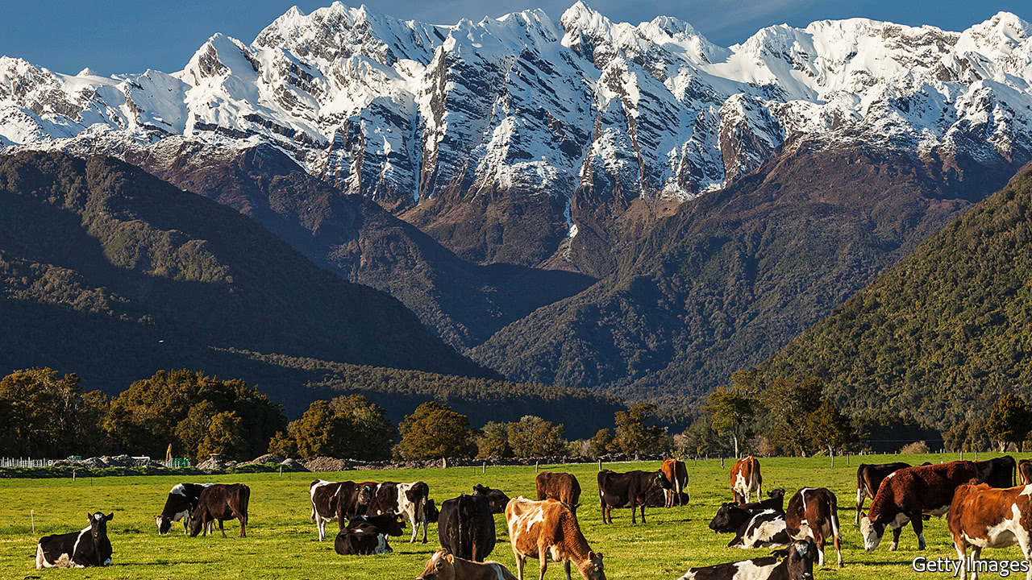

Are you interested in Agriculture and/or Horticulture?
If you are interested in working in any Primary Industry, Te Aho o Te Kura Pounamu can offer the opportunity to get a head start in your career. Agricultural unit standards from our specialist providers are available to work on at home. Students may begin these booklet based studies at any time of the year.
 | Level 1-2
Unit Standard | Description | Credit Value | Category
19139v3 | Gather and record information from a rain gauge, thermometer, and barometer; or weather station (L1) | 2 | Ag General
19116v4 | Demonstrate knowledge of livestock behaviour and animal welfare | 3 | Ag General
24542v2 | Describe the impact of an agriculture system on soils | 3 | Ag General
22174v2 | Demonstrate knowledge of soils and fertilisers | 5 | Ag General
19138v3 | Describe weather, climate and micro-climate characteristics, and interpret weather maps for a primary industry operation | 4 | Ag General
18191v4 | Demonstrate knowledge of safe handling and health problems of dairy cattle, associated with milking | 3 | Dairy
18192v4 | Demonstrate knowledge of how cows produce milk | 2 | Dairy
18193v4 | Describe farm dairy design, and the farm dairy effluent system | 2 | Dairy
19081v4 | Describe annual feed supply and demand, methods to manage feed surpluses and deficits, and perform calculations | 4 | Cattle
24623v2 | Demonstrate knowledge of breeds and classes of cattle, and identification and records for cattle | 2 | Cattle
19147v3 | Describe the activities and identify hazards in a wool shed during shearing from a farm perspective | 2 | Sheep
24641v1 | Demonstrate knowledge of features, attributes, identification, and records for sheep | 2 | Sheep
30791v1 | Demonstrate understanding of honeybee physical features, castes, bee stings and beehive health | 5 | Apiculture
30796v1 | Demonstrate understanding of the process, role and significance of plant pollination by bees | 3 | Apiculture
816v6 | Demonstrate knowledge of plant production in New Zealand | 5 | Horticulture
829v5 | Demonstrate knowledge of plant nomenclature | 5 | Horticulture
25158v2 | Demonstrate knowledge of the vegetable production industry in New Zealand | 5 | Horticulture
29499v2 | Identify a range of plants by botanical & common name, and their basic features | 2 | Horticulture
27213v2 | Identify & interpret agrichemical product information and demonstrate knowledge of safety with agrichemicals | 5 | Ag-chem & Pest control
 | Level 3
Unit Standard | Description | Credit Value | Category
19103v2 | Demonstrate knowledge of methods for promoting on-farm livestock health and health problems of livestock | 8 | Ag General
22175v3 | Describe soil properties and their effect on plant growth | 6 | Ag General
19140v3 | Describe water use and quality, and related land use issues in primary production | 5 | Ag General
18v6 | Demonstrate knowledge of animal anatomy and physiology | 4 | Ag General
28971v2 | Describe livestock reproductive processes and practices | 5 | Ag General
28974v2 | Describe livestock selection for increased productivity | 4 | Ag General
10087v4 | Describe and plan plantings for insect and bird retention for a given situation | 5 | Ag General
10082v3 | Demonstrate knowledge of rearing weaner or replacement cattle | 4 | Cattle
19075v2 | Demonstrate knowledge of calving, and associated diseases and health disorders | 3 | Cattle
24624v1 | Demonstrate knowledge of cattle genetics and selection | 5 | Cattle
19149v3 | Describe lambing, and the procedures for assisting ewes having difficulty lambing | 4 | Sheep
571v5 | Describe wool production in New Zealand | 5 | Sheep
15609v4 | Demonstrate knowledge of sheep milk production | 4 | Sheep
19157v2 | Demonstrate knowledge of sheep genetics, and ram selection | 5 | Sheep
30798v2 | Demonstrate understanding of bees, the bee lifecycle and the adult bee behaviour patterns | 4 | Apiculture
21031v5 | Identify annuals, herbaceous perennials, biennials, and bulbs used in amenity horticulture | 5 | Horticulture
771v5 | Demonstrate knowledge of the production horticulture industry in New Zealand | 5 | Horticulture
24648v3 | Describe the physical characteristics, and range of, woody stemmed plants and their use | 10 | Horticulture
27210v2 | Identify and describe weeds, and methods of prevention and control | 6 | Horticulture
29829v2 | Demonstrate knowledge of plant structure, functions and processes | 4 | Horticulture
19111v2 | Demonstrate knowledge of the types, breeds, uses, and health requirements of farm dogs | 4 | Farm Dogs

If you any questions about these Unit Standards or you would like to enrol please contact ces.lowe@tekura.school.nz

